Practice 1
Part 1
Test your knowledge:
1. Initiate an iSQL*Plus session using the user ID and password that are provided by the instructor.
2. iSQL*Plus commands access the database.
True/False
3. The following SELECT statement executes successfully:
SELECT last_name, job_id, salary AS Sal
FROM employees;
True/False
4. The following SELECT statement executes successfully:
SELECT *
FROM job_grades;
True/False
5. There are four coding errors in the following statement. Can you identify them?
SELECT employee_id, last_name
sal x 12 ANNUAL SALARY
FROM employees;
Part 2
Note the following location for the lab files:
E:\labs\SQL1\labs
If you are asked to save any lab files, save them at this location.
To start ISQL*Plus, start your browser. You need to enter a URL to access iSQL*Plus. The URL requires the host name, which your instructor will provide. Enter the following command, replacing the host name with the value that your instructor provides: http://<HOSTNAME:5561>/isqlplus
You have been hired as a SQL programmer for Acme Corporation. Your first task is to create some reports based on data from the Human Resources tables.
6. Your first task is to determine the structure of the DEPARTMENTS table and its contents.
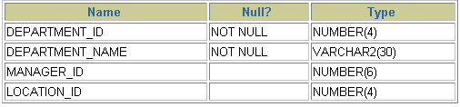
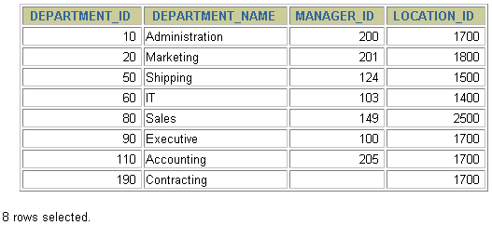
7. You need to determine the structure of the EMPLOYEES table.
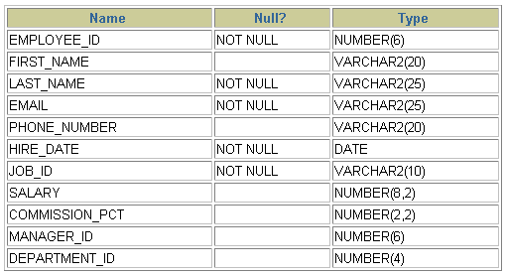
The HR department wants a query to display the last name, job code, hire date, and employee number for each employee, with employee number appearing first. Provide an alias STARTDATE for the HIRE_DATE column. Save your SQL statement to a file named lab_01_07.sql so that you can disperse this file to the HR department.
- Test your query in the lab_01_07.sql file to ensure that it runs correctly.
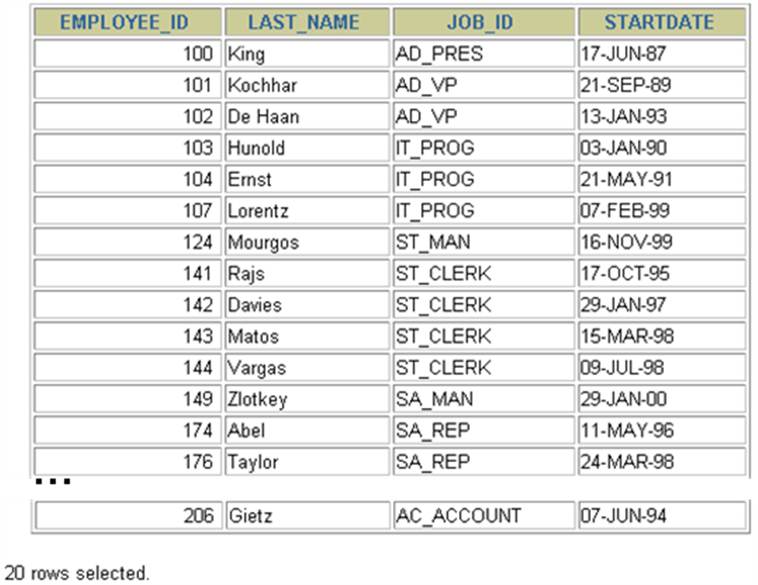
- The HR department needs a query to display all unique job codes from the EMPLOYEES table.

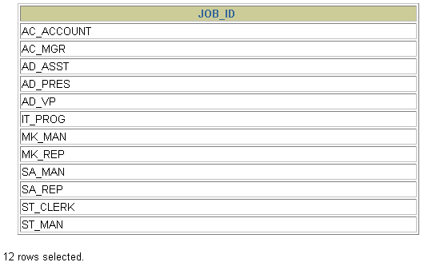
- The HR department wants more descriptive column headings for its report on employees. Copy the statement from lab_01_07.sql to the iSQL*Plus text box. Name the column headings Emp #, Employee, Job, and Hire Date, respectively. Then run your query again.
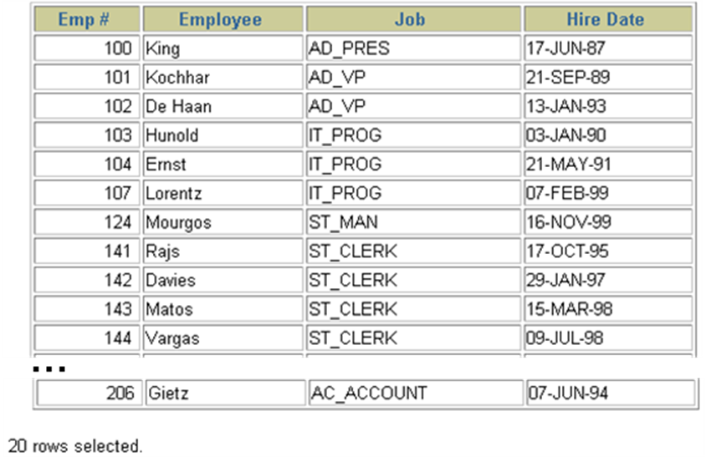
- The HR department has requested a report of all employees and their job IDs. Display the last name concatenated with the job ID (separated by a comma and space) and name the column Employee and Title.
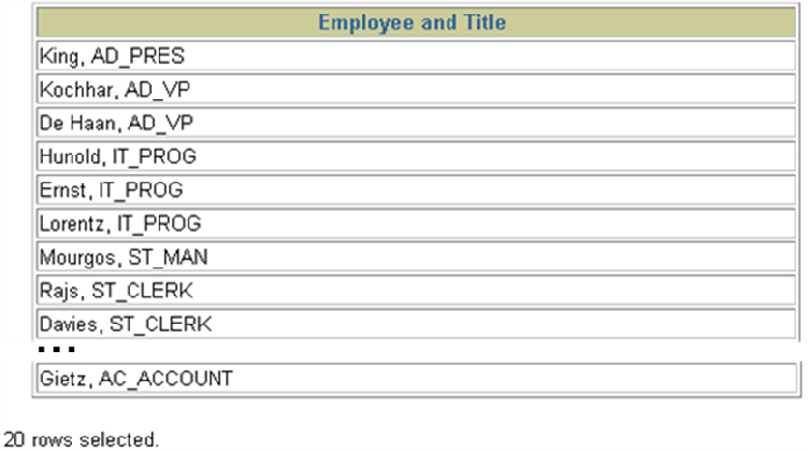
- To familiarize yourself with the data in the EMPLOYEES table, create a query to display all the data from that table. Separate each column output by a comma. Name the column title THE_OUTPUT.
